**PRINCIPAL’S SPECIAL NEWSLETTER ON SCHOOL FEES DISCOUNT TO BOARDERS**

Assalamau alaykum,

Dear parents,

Since the discount of 30% was given to both day students and boarders on the original fees paid, we have been inundated with calls from quite a few parents asking why shouldn’t boarders pay the same amount as day students, considering that both groups of students are at home as a result of closure of schools and the boarders are not enjoying any of the facilities of the hostel especially food.

After the school management explained to those who called, we were advised by the parents to send an explanation to other parents as to why the two groups of students cannot pay the same amount of fees.

Firstly, at the beginning of each financial year, calculations are made based on the expected expenditure during the year. This includes expenditure on exercise books, textbooks, provision of new and maintenance of old equipment and facilities, feeding of boarders, teaching resources, staff training, library books, staff salaries, students medicals, electricity supply, diesel for generators and repairs, rent for the school and hostel blocks which is paid to IET as Awqaf/endowment, funding of their charity/community welfare dawah activities, etc.

This amount is divided by the total number of students according to the category of boarders or day students and this is then divided into three terms as school fees. As a result, the amount charged to boarders goes beyond just feeding or is based on one term!

In addition, the school is still paying electricity bills, water bills, giving teachers credit for E-learning on days they cannot come to school, paying salaries of hostel staff, cooks, security, gardeners and cleaners in the hostel and those of teaching staff, as well as maintaining the hostels and school blocks, etc. We recently upgraded to a UK server which is a standalone and not shared plan, the school also upgraded its payment plan with Airtel to a business payment plan which is not also shared bandwidth similar to the type banks use. All this was to ensure that the E-learning experience for both staff and students runs smoothly.

As some of the parents who called requested, we have approached the management of the Islamic Education Trust for possible further discount on school fees. After the deliberation with them, they agreed to further cut down the rent on the buildings which the school occupies and the school made its own budget cuts in order to arrive at a further discount of 5% for boarding students. This is in consideration of the difficulties currently faced and the need to make sacrifices in recognition that times are hard for everyone.

As a result, SS3 and SS2 boarders will **pay N285, 350**, while JSS1-SS1 boarders will pay **N285,350 plus the N7,000** for the external ICT vendors.

Parents who have already made the 70% payment previously sent out will have the excess amount credited to their next term terms school fees in sha Allah.

May Allah bring an end to this pandemic and bring us back together safely after it is all over.

Wassalamu alaykum

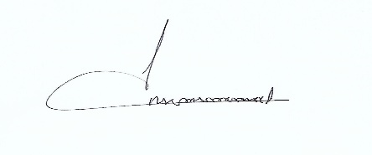

Mustafa Mas’ood

Principal